TICs

**NRC 5450:** Development web aplications

**Team 3:**

* Rubén González
* Diego Guzmán
* Lizeth Iza
* Steven Jaramillo

**Topic:**

Web page “*StoreOnline”*

**Teacher:**

Jorge Edison Lascano

25 de july de 2022

**Link to repository GitHub:**

* <https://github.com/Lizeth-Abigail-Iza-Moreno/ESPE202205-T3-AlphaCoders>

**Link to code:**

* <https://github.com/Lizeth-Abigail-Iza-Moreno/ESPE202205-T3-AlphaCoders/tree/main/06-Code>

**Captures of screen about criters evaluation**

1. Github Repository (Right Structure and collaboration)

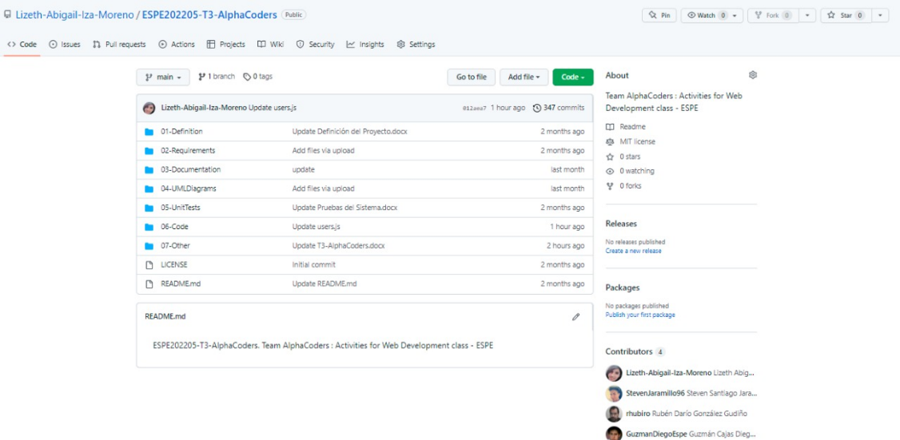

**(1) PUBLIC API CONSUMPTION**

**(2) USER INTERFACES FOR YOUR PROJECT**

1. Design (sketches) of the web pages

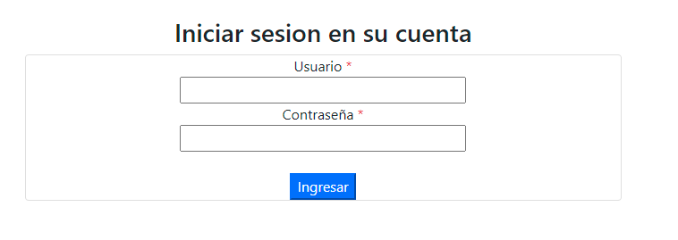

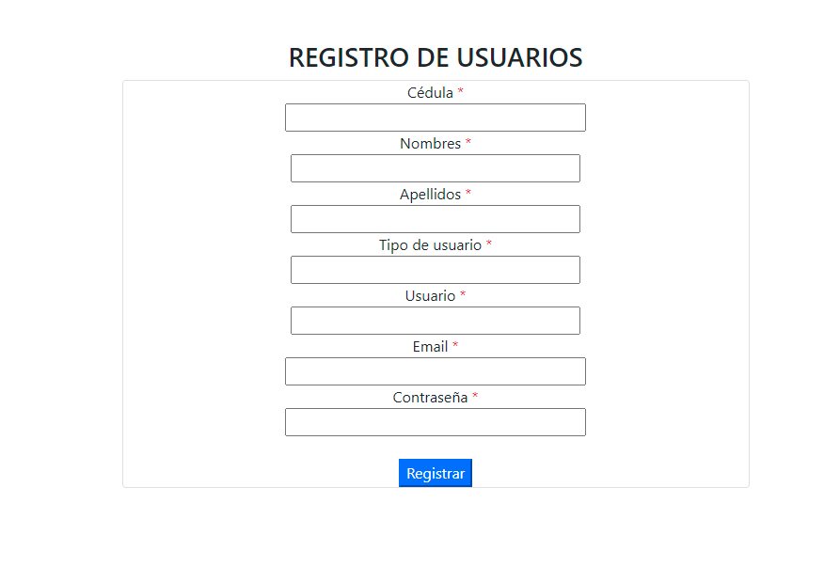

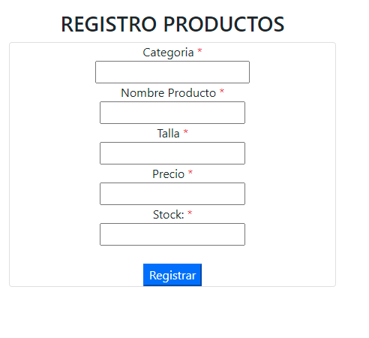

1. Authentication and Navigability
2. **Web Clients + public API**[***https://api.plos.org/search***](https://api.plos.org/search)

* You must also create a page that shows the information of the client computer from where you are accessing the API. For that, the public API that you are using provides the following URI <https://httpbin.org/get>. That URI returns the data of the client machine in JSON format. The data to be submitted are (in a web page, i.e., the data must be formatted as a web page, not JSON):
* The files that are accepted
* The language
* The remote host
* The IP that originated the request
* The name of the browser
* The Operating System of the local machine

* <https://httpbin.org/get>

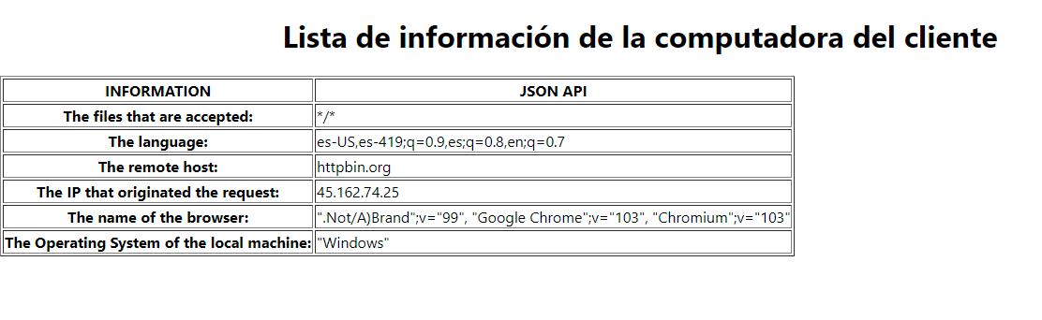

1. Web Clients + Web Service + BDD

**URI** <http://3.86.165.121:3003/onlinestore/products>

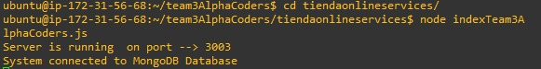

Server running in the VM hearing on port 3003

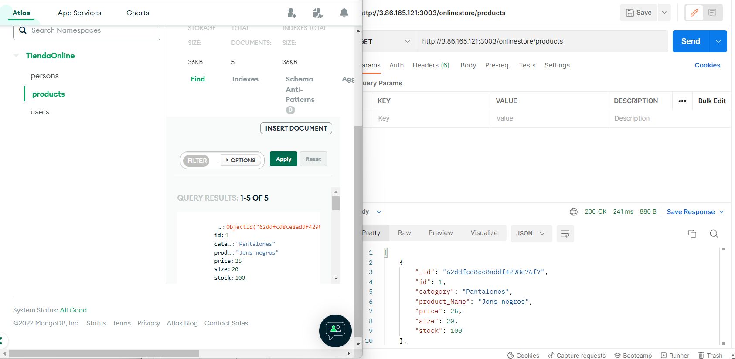

Data at MongoDB and retrieve with Postman using Uri

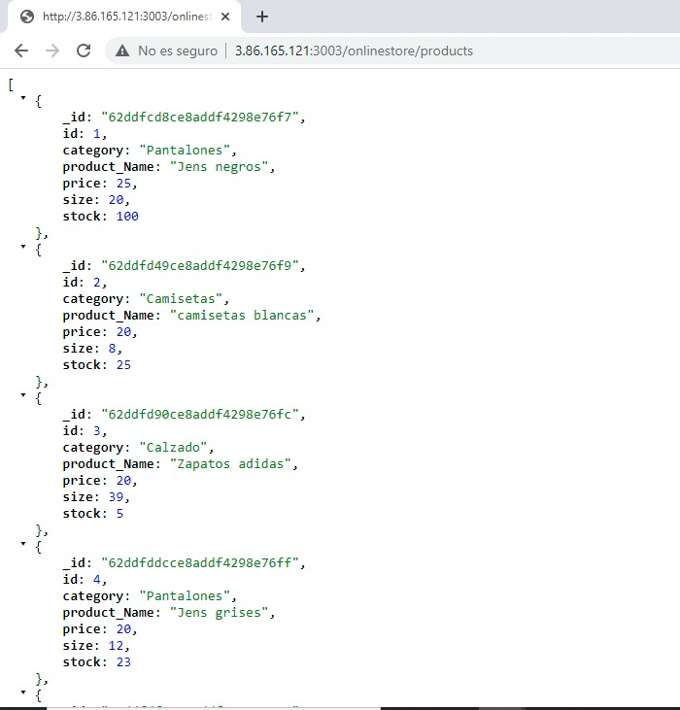

Other kind of retrieve, from a navigator.